HandsMen Threads
Elevating the Art of Sophistications in Men’s Fashion
Capstone Project – Salesforce Demo Documentation

Author: Garcia, Joseph John V.
Date: November 27,2025
Environment: Salesforce Developer Org / Lightning Experience

Table of Contents
1. Project Overview
2. Custom App & Architecture
3. Data Model and Key Fields
4. Creating Data Records Step by Step
5. Business Automations Flows and Scheduled Processes
6. Apex Triggers and Batch Jobs Summaries
7. Email Templates Placeholders
8. Testing Validation and QA Scenarios
9. Reports and Dashboards Placeholders
10. Deployment Notes and Permissions
11. Future Scope and Recommendations
12. Appendix Sample SOQL and Test Checklist

Project Overview
Project name: HandsMen Threads
Description: A custom Salesforce CRM to manage bespoke men’s tailoring: customers, products, inventory, orders, loyalty tiers, and automated communication.
Business goals
- Streamline tailoring workflows from inquiry to delivery
- Improve customer experience with personalized interactions and loyalty rewards Ensure accurate inventory and order management to avoid stock issues
- Automate routine processes to reduce manual work and accelerate fulfillment
Salesforce tools used:
- Custom Objects and Tabs
- Lightning Custom App
- Record-Triggered Flows and Scheduled Flows
- Validation Rules and Email Alerts
- Apex Triggers and Batch Apex
- Reports and Dashboards

Script for Project Overview tab
HandsMen Threads is a specialized Salesforce CRM solution tailored for the bespoke menswear industry. Designed to optimize operations, the project focuses on automating business processes, managing inventory, and enriching the customer experience through personalization. Leveraging a technical stack that includes Custom Objects, Apex Triggers, Flows, and advanced reporting, this demo provides a comprehensive walkthrough of the system’s architecture and end-to-end functionality.
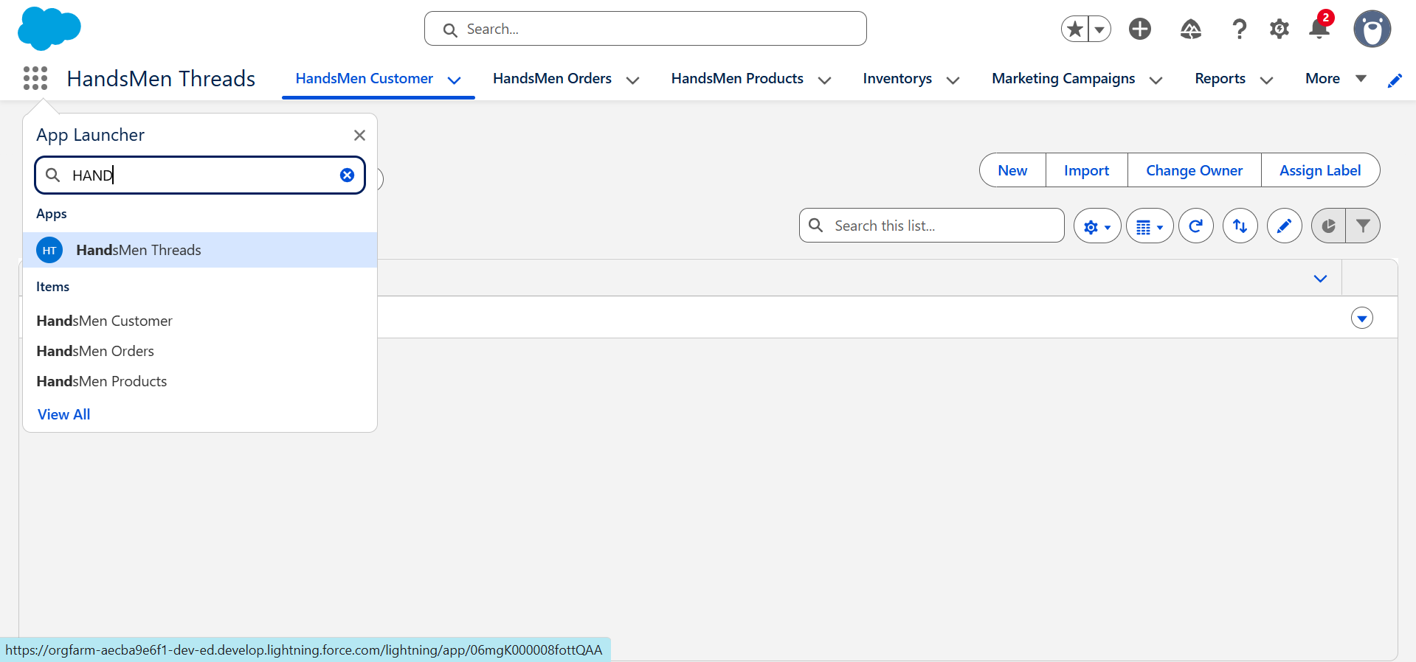
Custom App and Architecture
Custom App: HandsMen Threads Lightning App — central hub for operations and admin tasks Assigned profiles: System Administrator, Sales, Service, Inventory Manager
Object architecture
Custom Objects
- Handsmen Customer — customer name, email, phone, loyalty status, total purchases
- Handsmen Orders — order number, product, customer, status, quantity, total amount, customer email
- Handsmen Products — SKU, price, name, stock quantity
- Inventory — product, stock quantity, warehouse location
- Marketing Campaigns — campaign number, customer, start date, end date

Standard Objects used
- Accounts and Contacts
- Reports and Dashboards
Data flow
Customer → Orders → Product → Inventory. Orders update Inventory when confirmed; scheduled processes reconcile pending orders with stock.
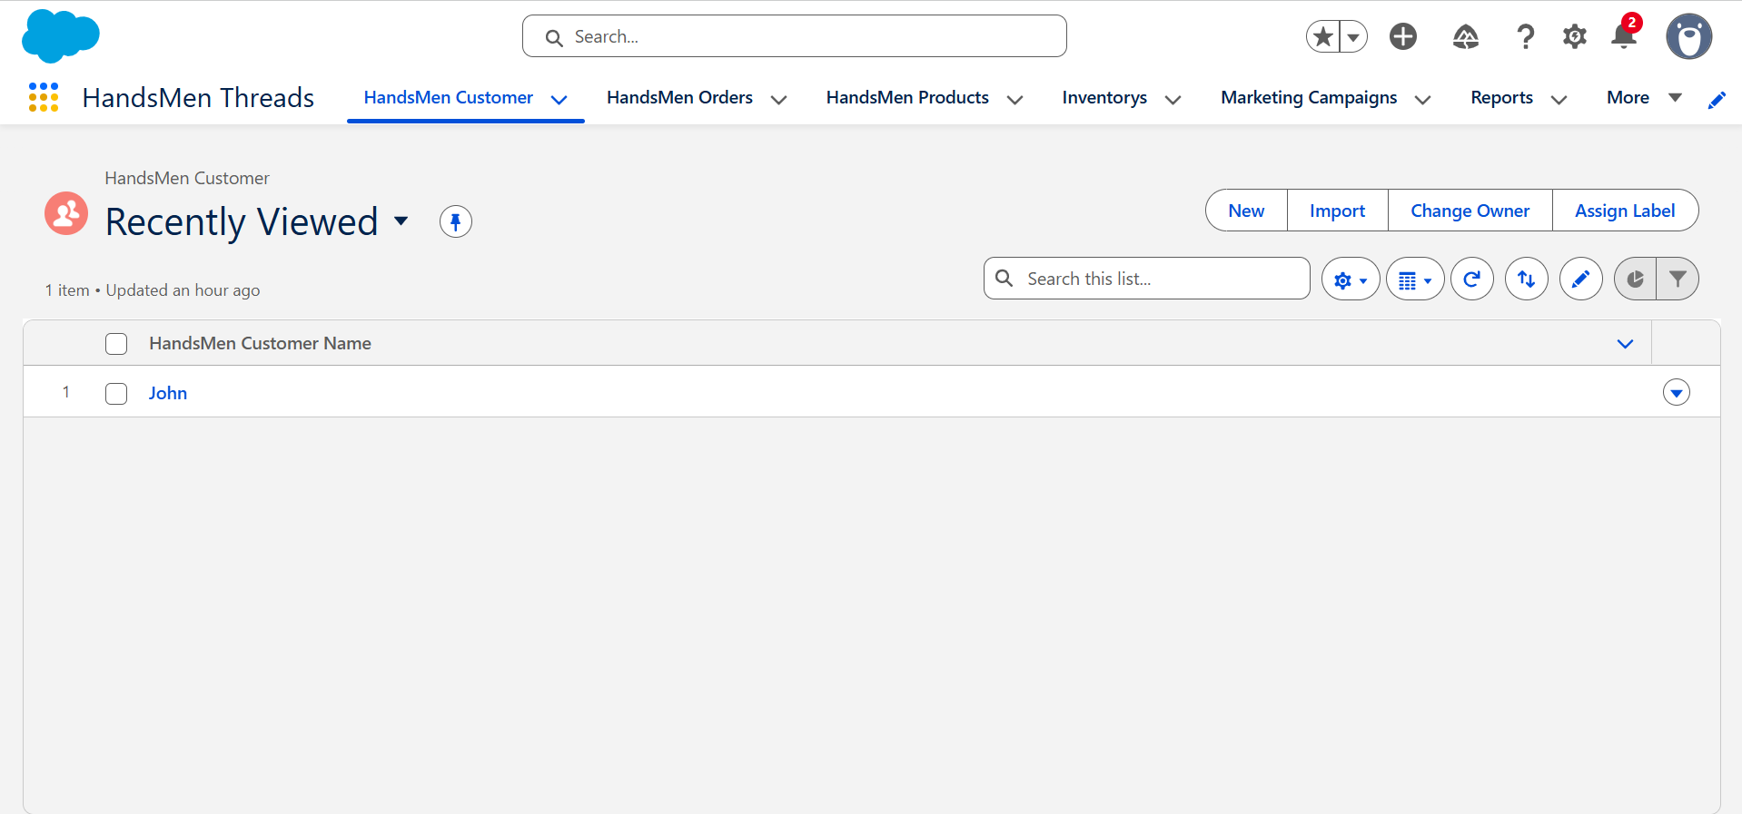
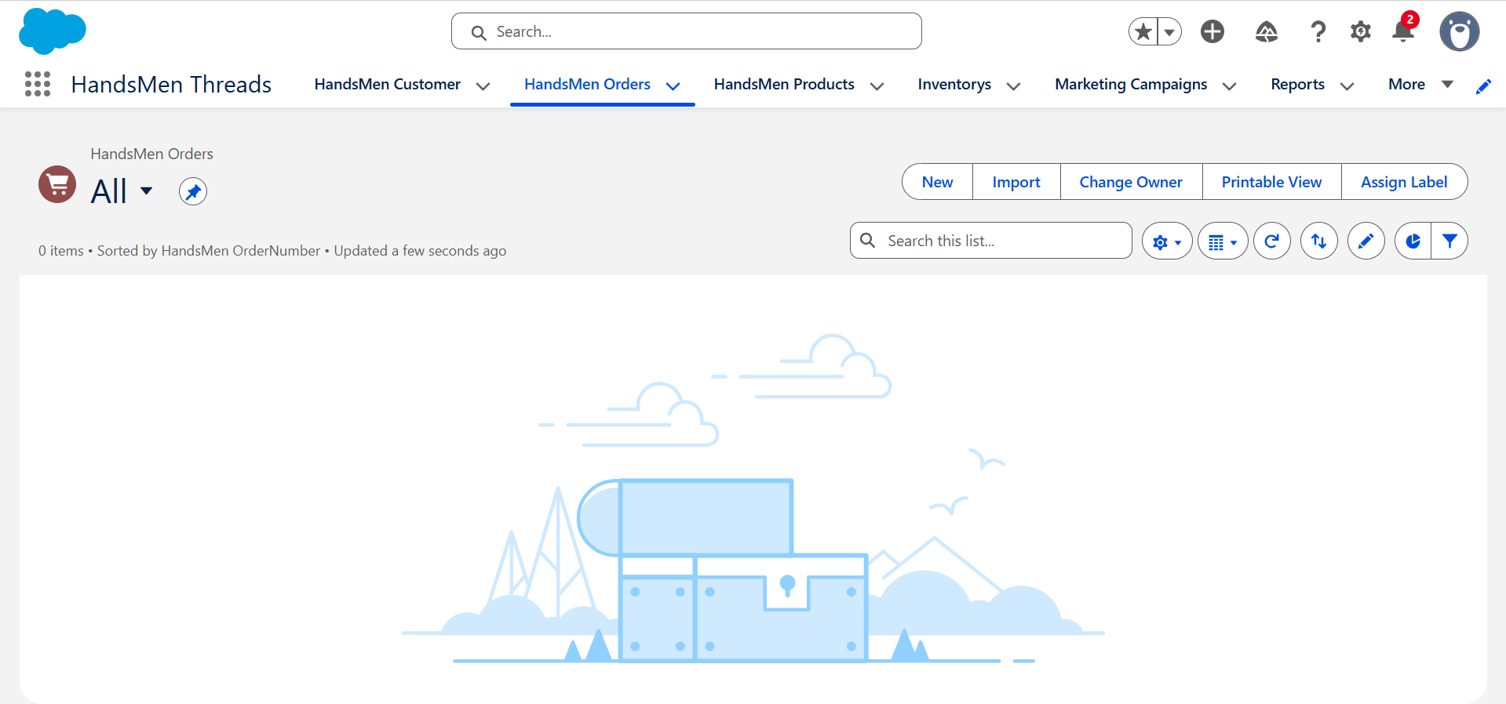
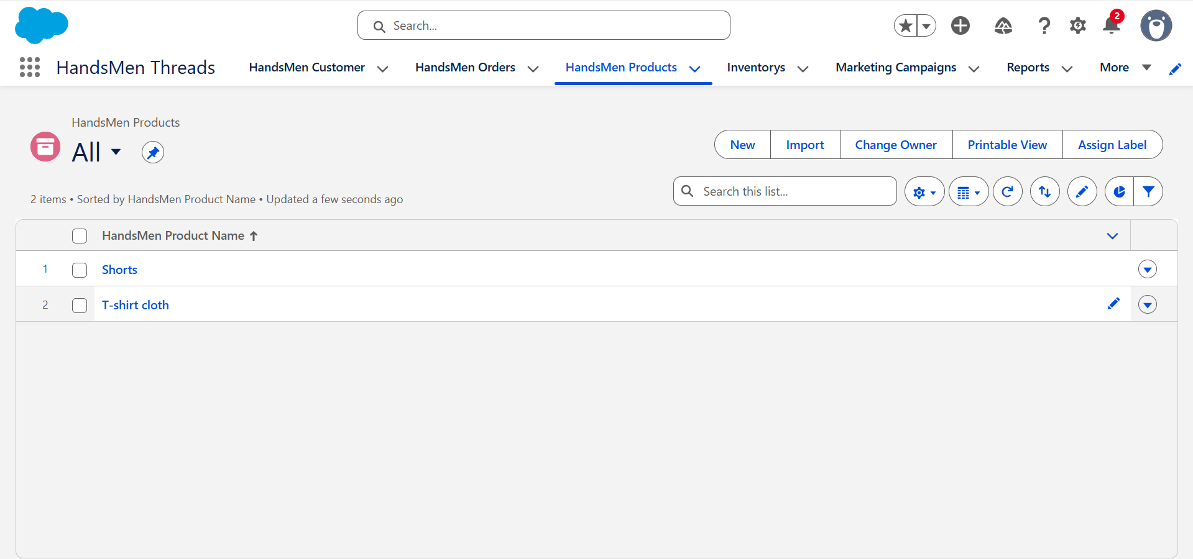
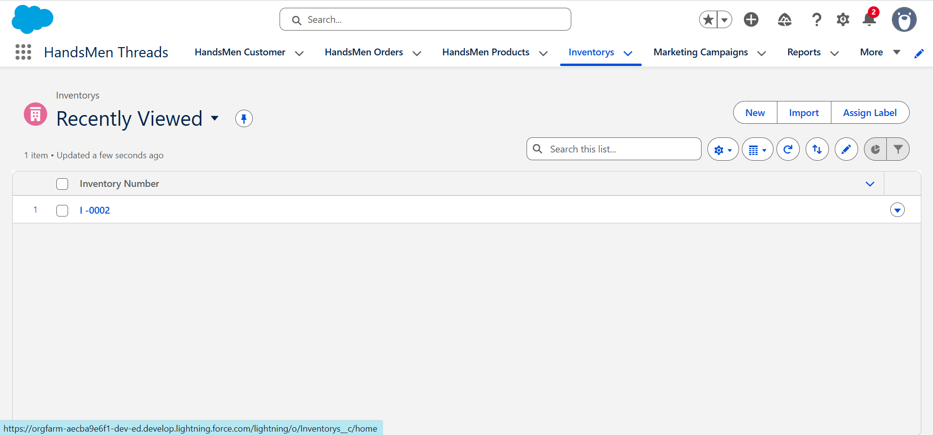

Data Model and Key Fields
Handsmen Customer
- FullName
- Email
- Phone
- Loyalty_Status__c
- Total_Purchases__c
Handsmen Products
- SKU__c
- Name
- Price__c
- Stock_Quantity__c
Inventory
- HandsMen_Product__c (Master-Detail)
- CreatedById
- Stock_Quantity__c
- Stock_Status__c
- Warehouse__c
Handsmen Orders
- Name (Order Number)
- HandsMen_Customer__c (lookup)
- Customer_Email__c
- HandsMen_Product__c (lookup)
- Quantity__c
- Status__c (Pending Confirmed Cancelled)
- Total_Amount__c
- Order_Date__c

Validation rules example
Email must contain “gmail.com” → Error text: Please fill correct Gmail
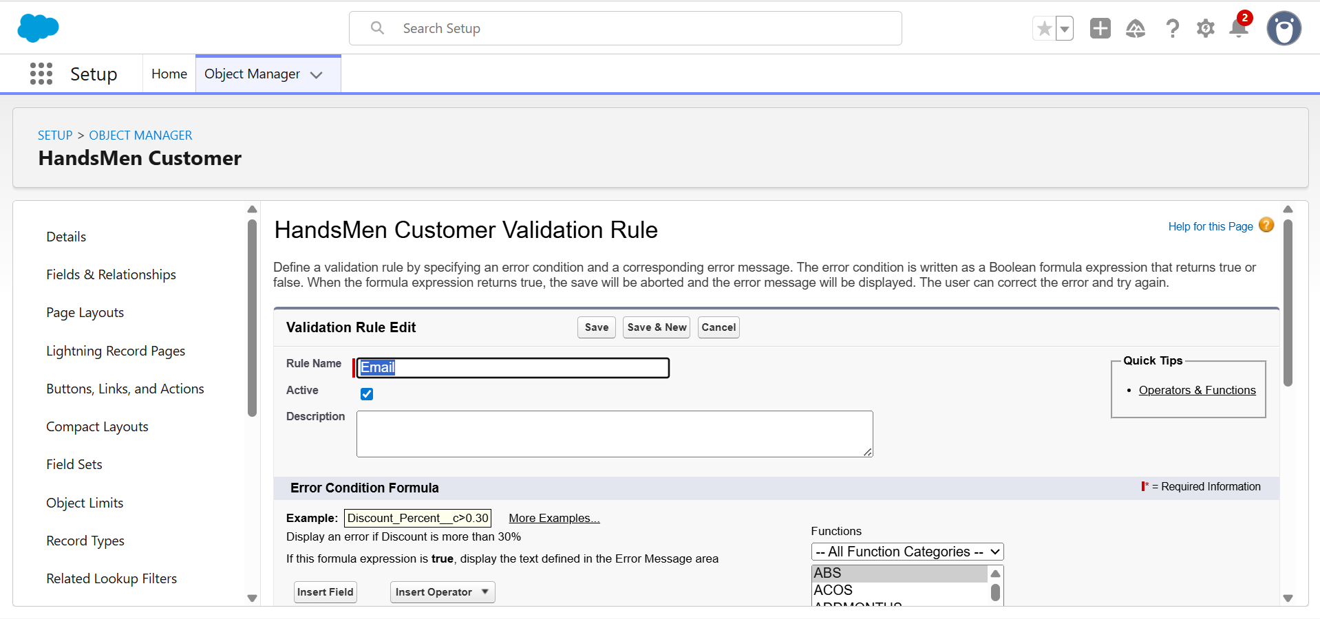

Creating Data Records Step by Step
1 Create Handsmen Customer
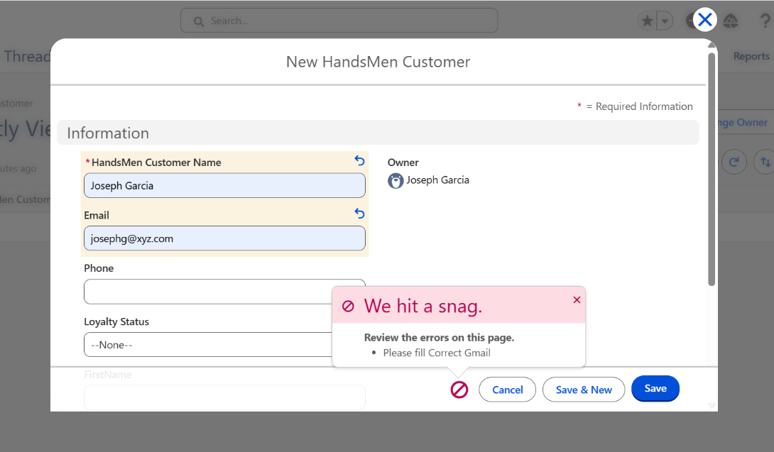
Steps: App Launcher → HandsMen Threads → New Handsmen Customer → fill fields → Save Demo note: Enter invalid email "josephg@xyz.com" → validation error "Please fill correct Gmail" → change to "josephg@gmail.com" → Save success.

2 Create Handsmen Product
Fields: Order Name: Shorts; SKU:0002; Price: $3; Quantity: 1000;
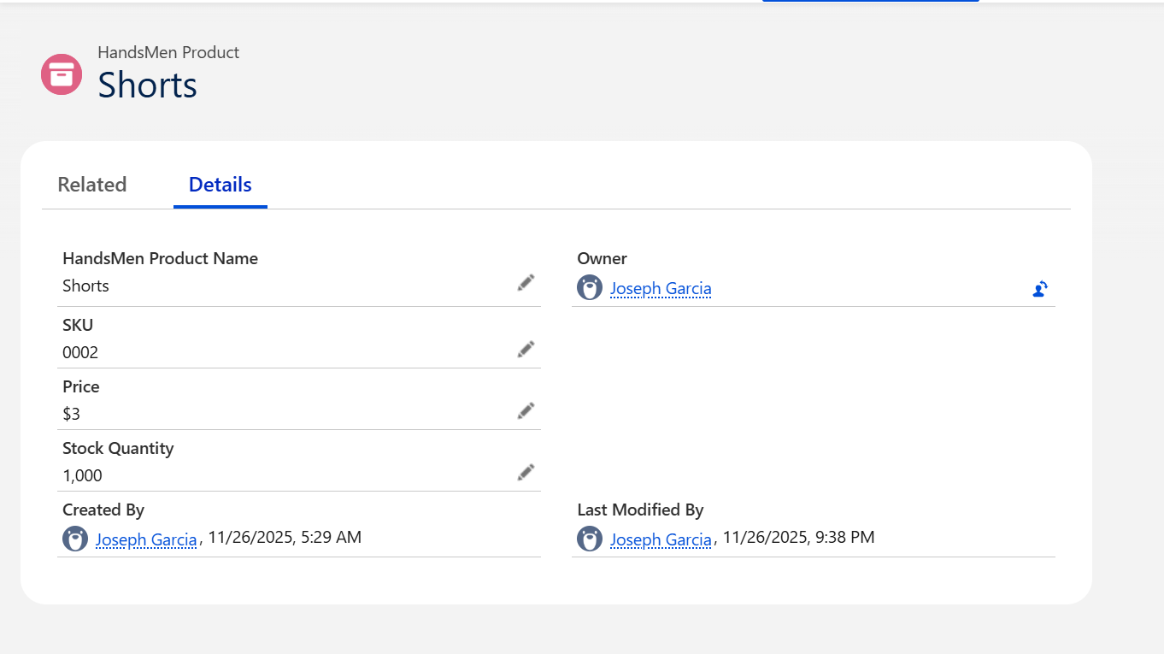
3 Create Inventory Record
New product → Handsmen Product Shorts → Stock Quantity 1,400 → Warehouse Shorts.
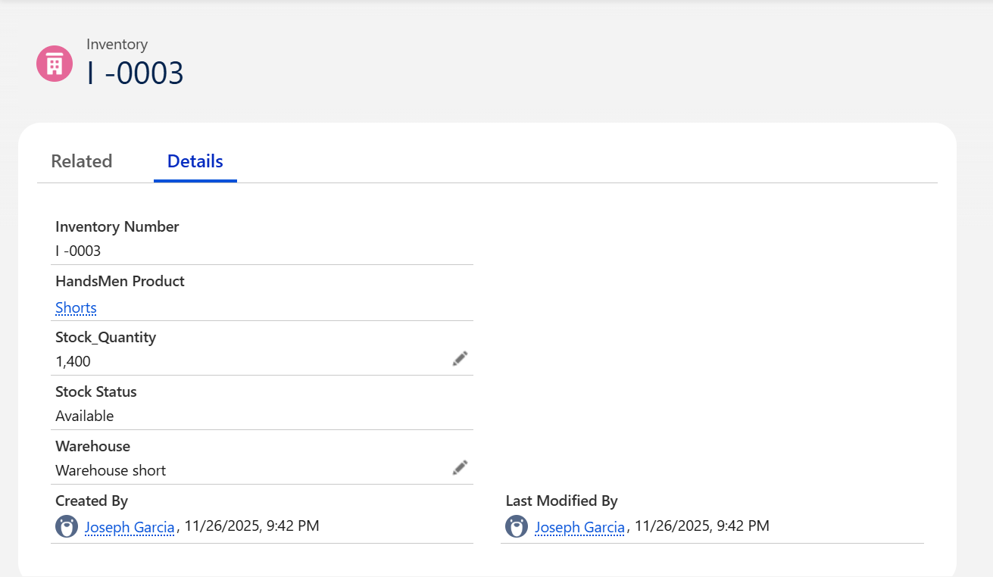

4 Create an Order
Handsmen Orders → New select Customer Product Quantity → Save→Total Amount auto-calculates via Apex.
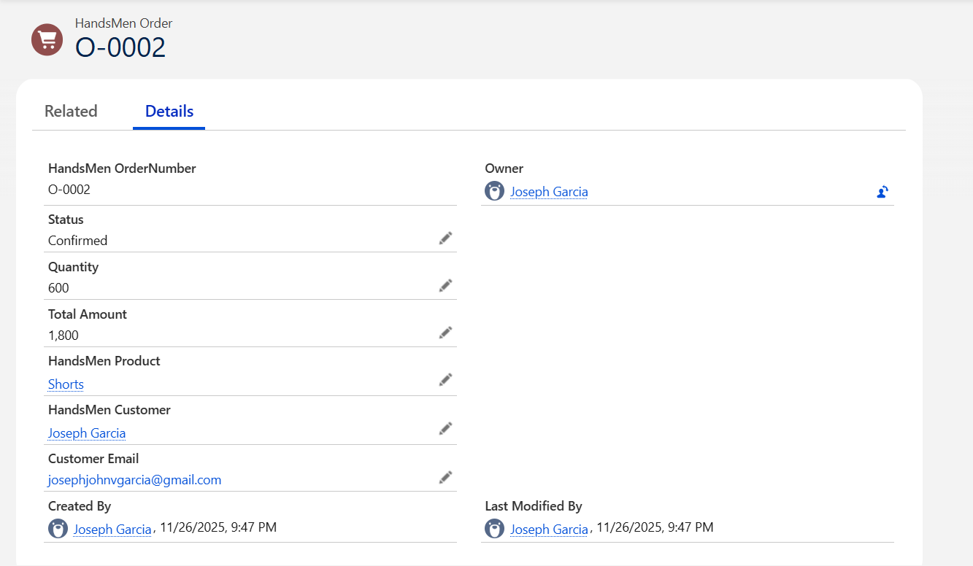
Business Automations Flows and Scheduled Processes
This section details automations to demonstrate system intelligence.
Automated Order Confirmation Record Triggered Flow
Trigger: Order.Status changes Pending → Confirmed
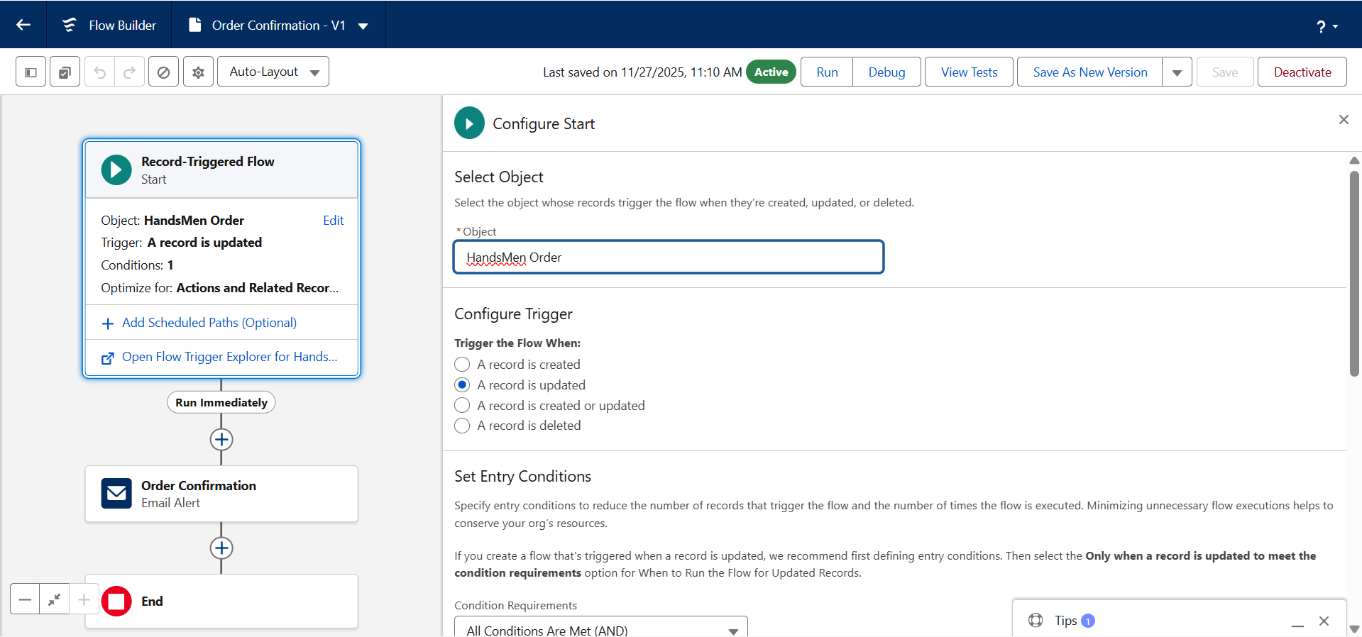
Actions: Send confirmation email to customer; update Inventory.Stock_Available minus Quantity Demo example: Joseph G orders 600 shorts; stock 2000 → new stock 1400; confirmation email sent.

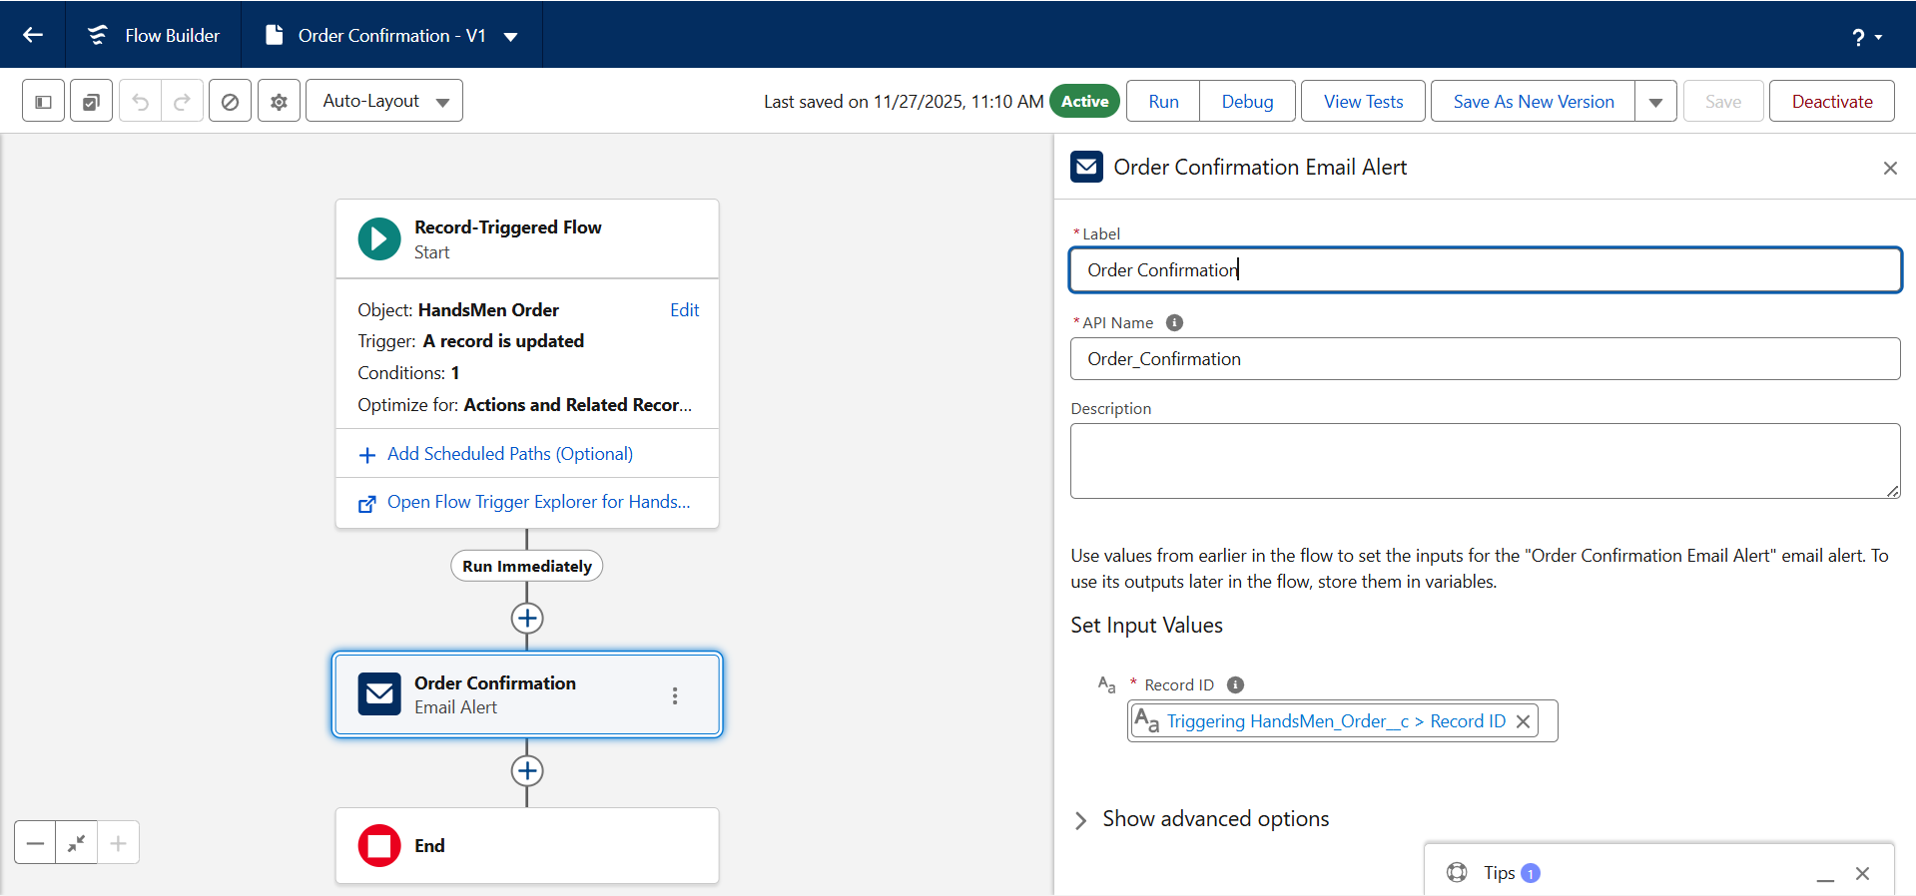

Low Stock Alert Record Triggered Flow

Trigger: Inventory update
Condition: Stock_Quantity < 5
Actions: Send low-stock email to inventory manager
Sample email:
Dear Inventory Manager,
This is to inform you that the stock for the following product is running low:
Product Name: {!Inventory__c.HandsMen_Product__c}
Current Stock Quantity: {!Inventory__c.Stock_Quantity__c}
Please take the necessary steps to restock this item immediately.
Best Regards,
Inventory Monitoring System
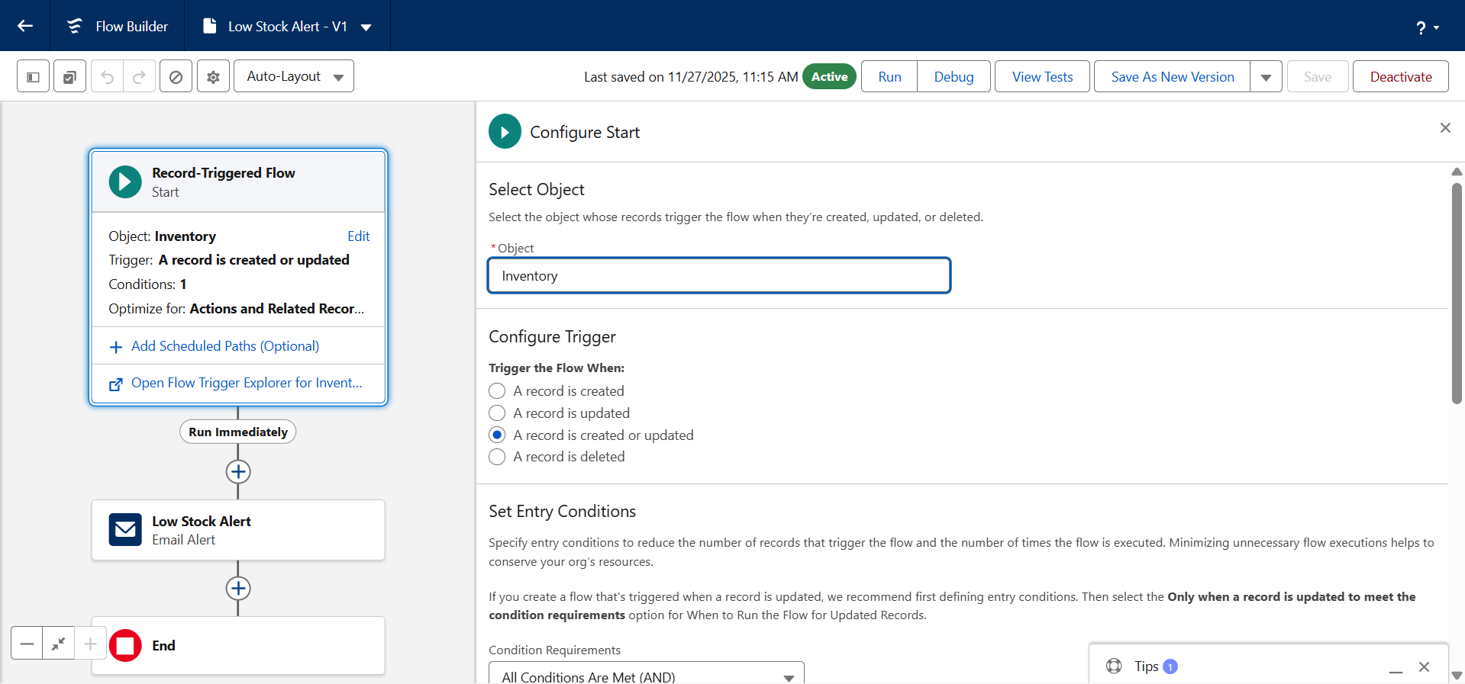
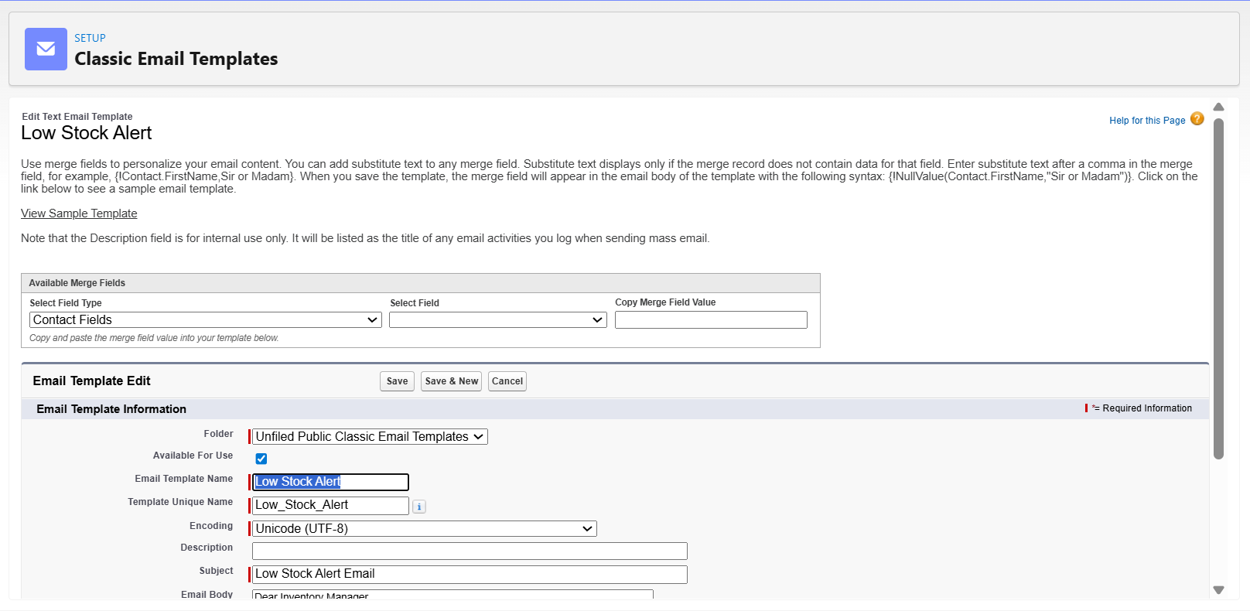
Loyalty Program Scheduled Flow
Schedule: Daily
Logic: Total_Purchases thresholds set Loyalty_Status
1000 Gold
500–1000 Silver
≤ 500 Bronze
Actions: Update Loyalty_Status__c and send status update email
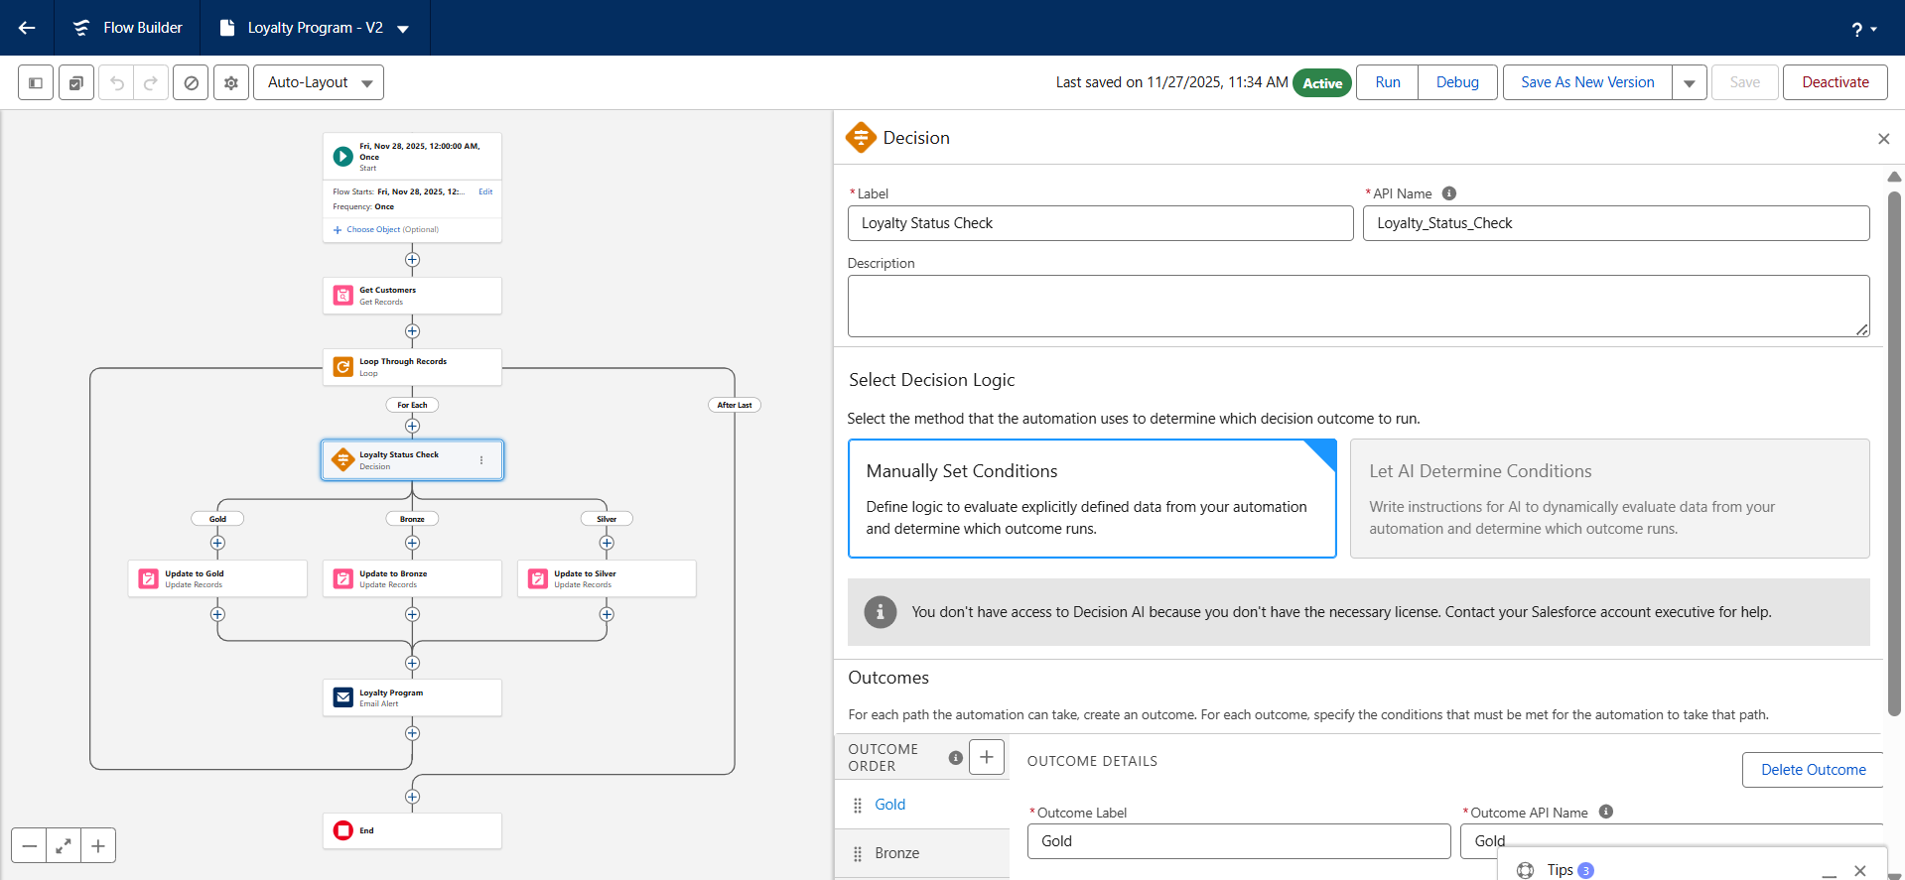

Apex Triggers and Batch Jobs Summaries
Order Total Calculation Trigger
When before insert before update on Handsmen Orders
Function: order.Total_Amount__c = order.Quantity__c *product.Price__c;Total_Amount__c = Product.Price__c × Quantity__c
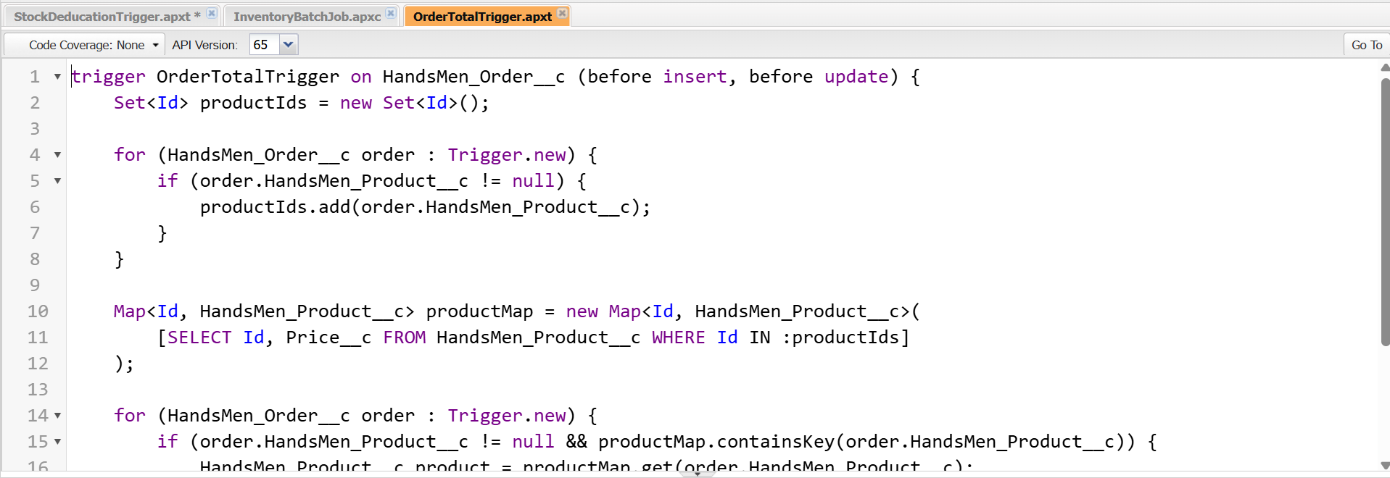
Stock Deduction Trigger
Use-case: Automatic deduction of stocks
Function: inv.Stock_Quantity__c -= order.Quantity__c;

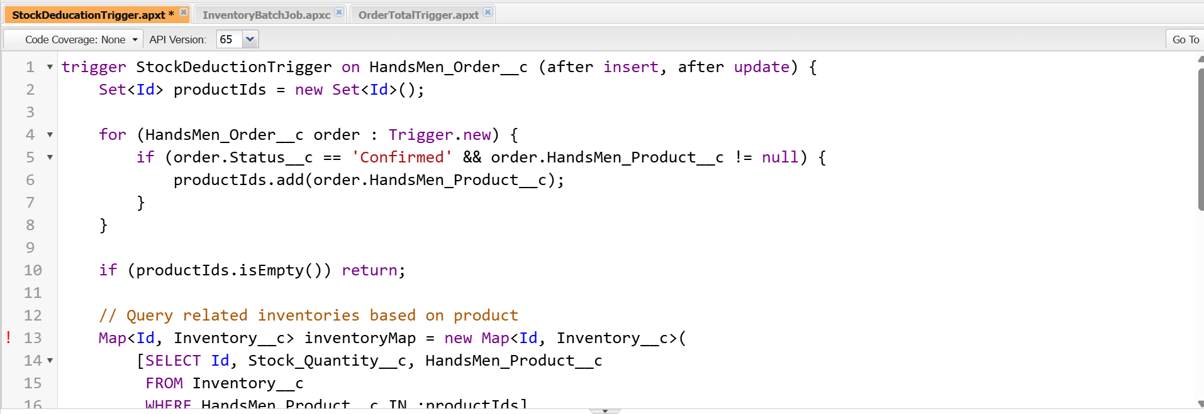

Email Templates Placeholders

Order Confirmation Email

Subject: Your order #{!HandsMen_Order__c.Name} has been confirmed!
Body sample:
Dear {!HandsMen_Order__c.HandsMen_Customer__c},
Your order #{!HandsMen_Order__c.Name} has been confirmed!

Thank you for shopping with us.

Best Regards,
Sales Team

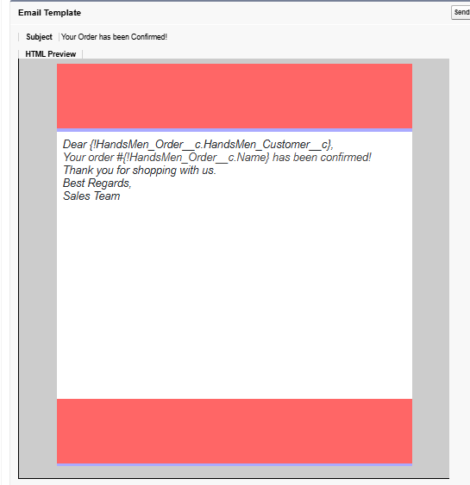

Low Stock Alert Email

Subject: Current Stock Quantity: {!Inventory__c.Stock_Quantity__c}
Body sample:

Dear Inventory Manager,

This is to inform you that the stock for the following product is running low:
Product Name: {!Inventory__c.HandsMen_Product__c}
Current Stock Quantity: {!Inventory__c.Stock_Quantity__c}
Please take the necessary steps to restock this item immediately.

Best Regards,
Inventory Monitoring System

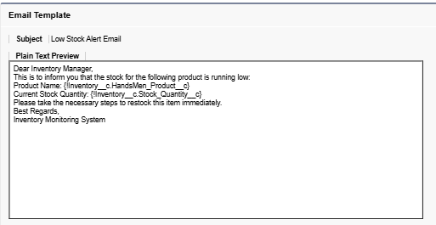

Loyalty Status Update Email
Subject: Congratulations! You are now a {!HandsMen_Customer__c.Loyalty_Status__c} member
Body sample:
Congratulations! You are now a {!HandsMen_Customer__c.Loyalty_Status__c} member and you are
eligible for our Loyalty Rewards Program.

Enjoy exclusive discounts, early access to offers, and special member benefits.
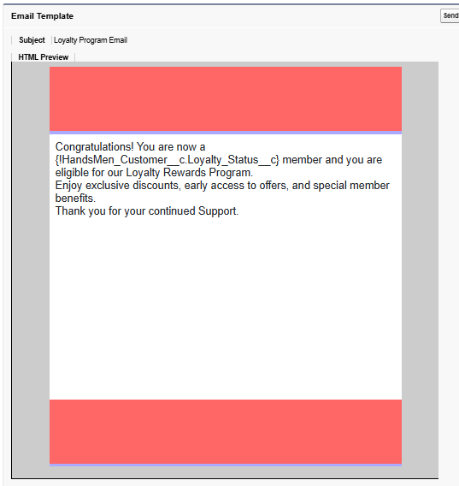
Thank you for your continued support.

Conclusion
HandsMen Threads effectively unifies diverse business functions—ranging from customer profiles and order lifecycles to inventory control and loyalty incentives—all supported by intelligent automation and custom Apex logic. Ultimately, this project demonstrates the power of Salesforce to modernize the bespoke tailoring business, resulting in streamlined operations, a superior client experience, and the ability to leverage real-time data insights.

